Damu Fund: Islamic finance has a huge potential for development in Kazakhstan

In recent years, banking products and instruments based on Islamic finance have been actively developing in Kazakhstan alongside with traditional ones. People who are not familiar with it often have some dissonance, although in fact Islam and finance are not incompatible concepts. While traditional finance is regulated by government organizations and directly by the market, Islamic finance (the "IF") is based on the principles of Shariah.
Islamic finance prohibits taking interest on loans (riba) and investing in haram activities such as casinos, enterprises involved in production and sale of alcohol and tobacco. In addition, the IF is an instrument to access financing with its own ethical and sustainable benefits. Thanks to this, banks and microfinance organizations operating on the principles of Islamic finance look more socially responsible, since the main advantage of IF over the traditional and capitalist model is that it is a system that assumes the concept of risk sharing between financiers and clients. An Islamic financial institution must strengthen the financial position of its clients, in which case the financiers will make a profit.
The number of Islamic financial institutions is growing steadily in the world. Even well-known world banks (HSBC, UBS, Citibank, and Goldman Sachs) open Islamic “windows” or subsidiaries as being their part, not only in Islamic countries, but also in the predominantly Christian USA, Great Britain, Germany, and France. At the same time, the Islamic finance market for the previous 3 years has shown that it has not reached maturity and continues to grow dynamically. From the beginning of 2017 to 2020, the growth in the volume of financing with the help of Islamic finance in the world grew by almost a quarter, while the growth for the traditional financial sector remains at the level of 5%.
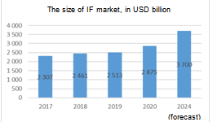 | 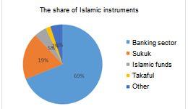

At the beginning of 2021, the total volume of the global Islamic finance market is over $ 2.9 trillion, the majority of which is occupied by the banking sector - 69% and the Sukuk Islamic bonds sector - 19%. Also, according to forecast report by the Islamic Development Bank (the “IDB”), the Islamic finance market will reach $ 3.7 trillion by 2024. It is worth noting that the Islamic banks’ share in traditional banking sector assets amounts to 6% globally.
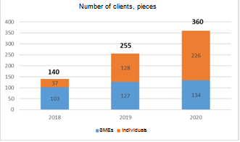 | 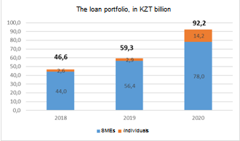
There are four main competitors in the IF market in Kazakhstan: Al Hilal Islamic Bank JSC, Kazakhstan Ijara Company JSC (KIC), Islamic Bank Zaman-Bank JSC, Al Sakr Finance JSC (ALSF). According to the analysis by the Damu Entrepreneurship Development Fund, as of January 1, 2021, the loan portfolio of Islamic financial institutions amounted to about 92.2 billion tenge, by giving twofold increase over the past 3 years. SMEs have made up the bulk of portfolio with a share of 85%. The number of active borrowers is 360 with an increase of more than 2.5 times over the past 3 years. The share of SMEs among borrowers is about 37%. In addition, according to the Spiritual Directorate of Muslims of Kazakhstan, the share of Muslims of the country’s population is about 70%.
“The Islamic finance market in Kazakhstan is growing very dynamically and has great potential,” says the Deputy Chairman of the Board of the Damu Entrepreneurship Development Fund Farhat Sarsekeyev. - Therefore, in 2021 we began cooperation with such Islamic financial institutions as Al Hilal Islamic Bank and Kazakhstan Ijara Company to increase the coverage of government support measures for business entities. We jointly launched a pilot Islamic finance program. Within the framework of this program, the Fund placed funds in the amount of 14 billion tenge for subsequent lending to SMEs”.
Even today we can talk about the first successful outcomes of the program. In total, the program participants supported more than 90 projects of SMEs, which created more than 200 new jobs and paid taxes to the budget for a total of 340 million tenge.
In addition, not stopping at what has been achieved, the Fund continues to develop new areas of financing for SMEs. So in July of this year, within the framework of the XII International Economic Summit “Russia - Islamic World”, the Damu delegation met with the CEO of the Islamic Corporation for Development of the Private Sector (ICD) Mr. Ayman Amin Sejiny. During the meeting, issues of cooperation were discussed, including attracting funding from ICD through the issue of Islamic Sukuk bonds, and it was also proposed to consider the provision of funding through the issue of Sukuk bonds. The implementation of these agreements will bring the development of Islamic finance in Kazakhstan to a new level.

